Project Report - Scale-space blob detection

Kautuk R Desai – 50247648

* Butterfly image:
* k: 1.50
* num of levels: 7
* sigma: 3.00
* Threshold: 0.0100.

Using image down sample method:

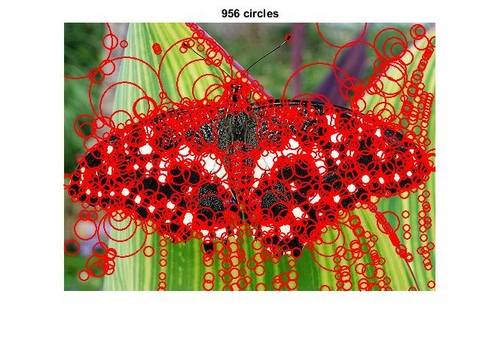

Using Filter size up sample method:

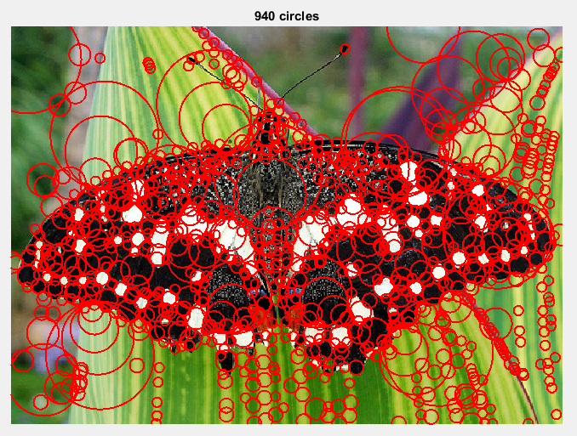

* The number of blobs detected is different from down sample image. Otherwise everything is the same. I mean, the change in intensity in the background is detected by.
* This is the same for the other images too; I have attached both the results for reference.

Using Difference-of-Gaussian method:

* 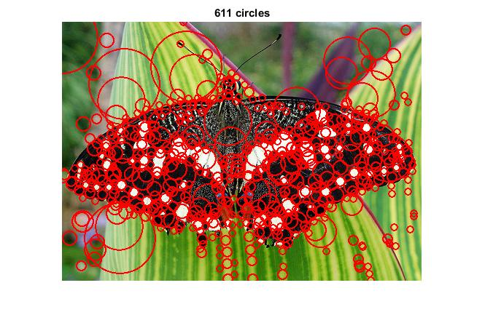

**Sunflowers:**

* k: 1.50
* num of levels: 7
* sigma: 3.00
* threshold: 0.0100

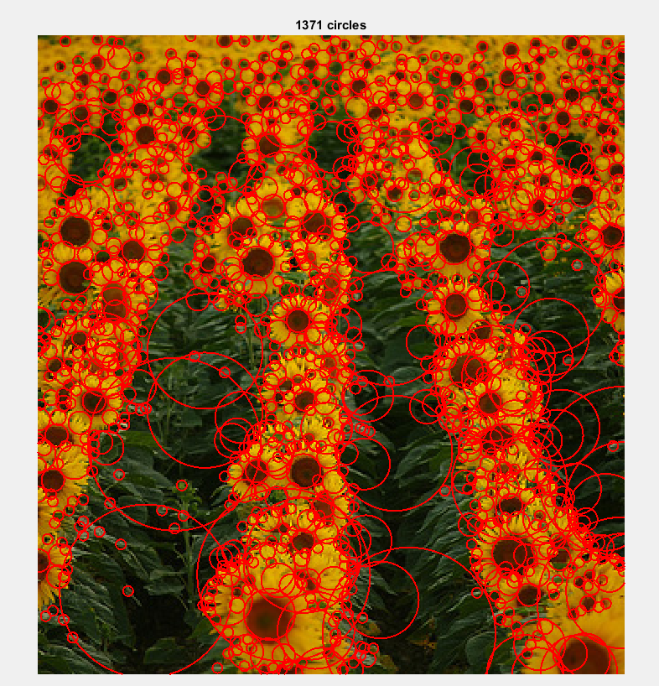

Up sample filter size method:

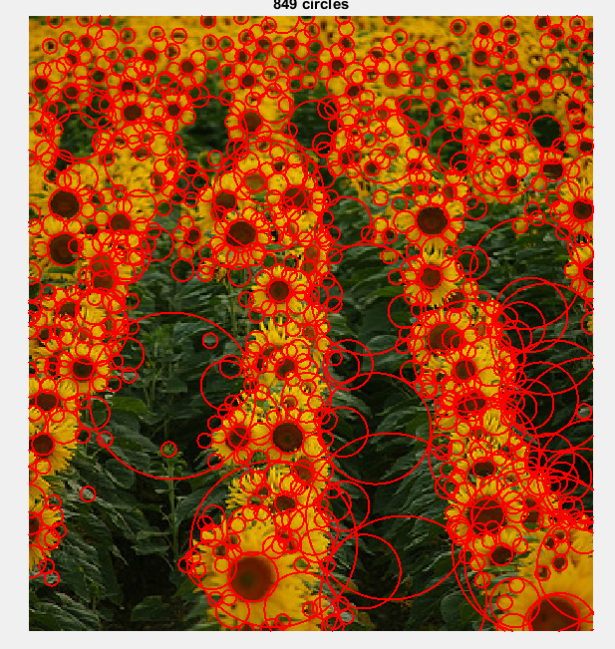

DoG Method:

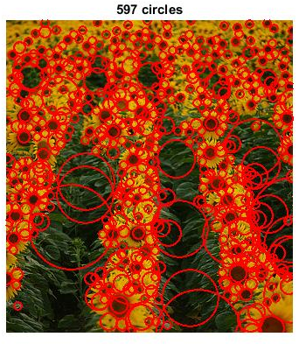

* **Einstein**
* k: 1.50
* num of levels: 7
* sigma: 3.00
* threshold: 0.0045

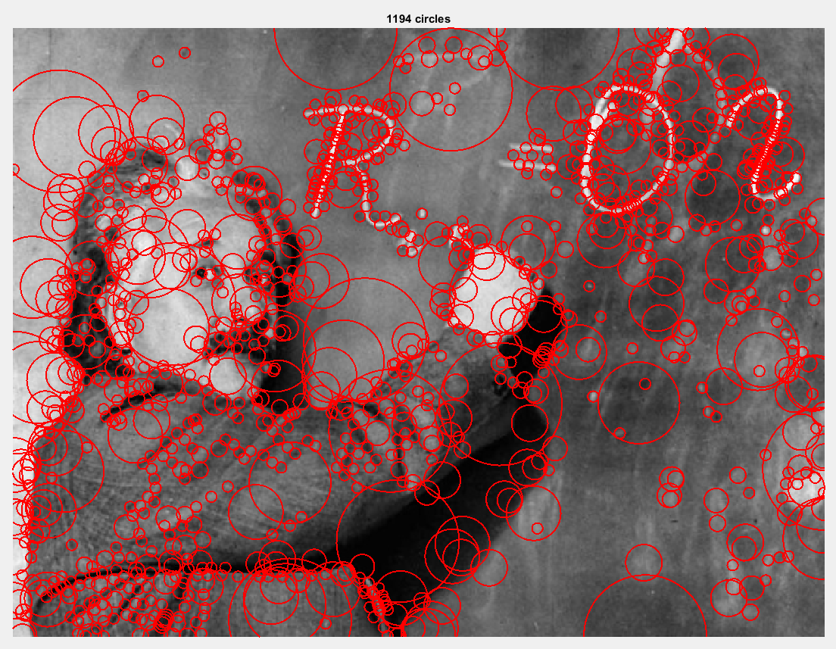

Up sample filter size method output:

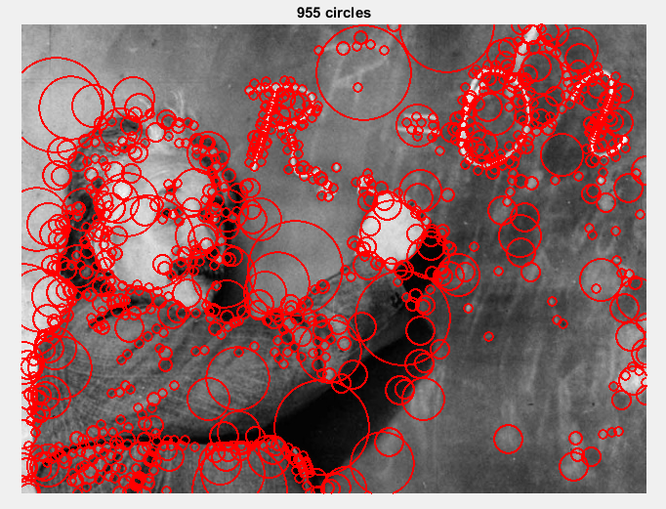

DoG Method:

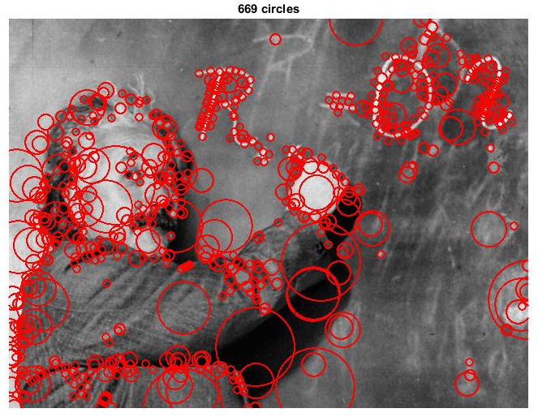

* **Fishes**
* k: 1.50
* num of levels: 7
* sigma: 3.00
* threshold: 0.01

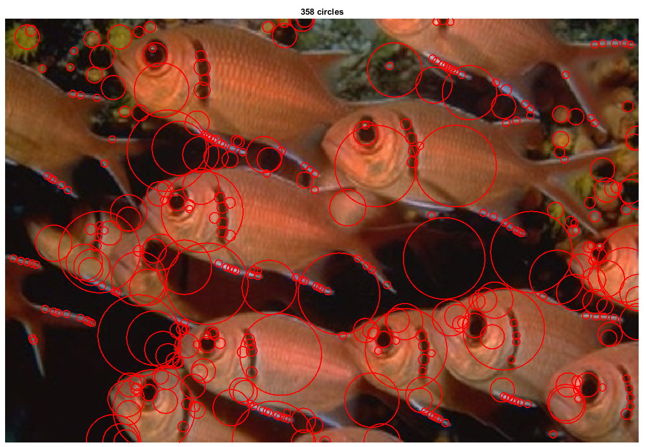

DoG Method:

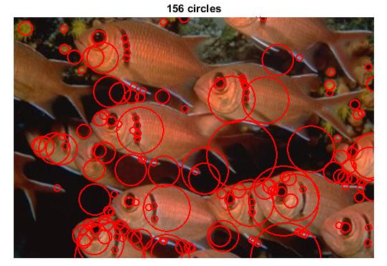

* **Football**
* k: 1.50
* num of levels: 7
* sigma: 2.00
* threshold: 0.01

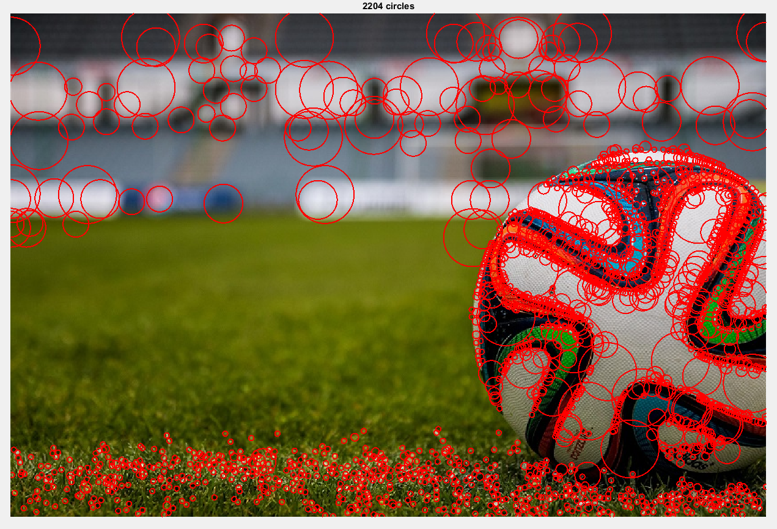

Up sample filter size method:

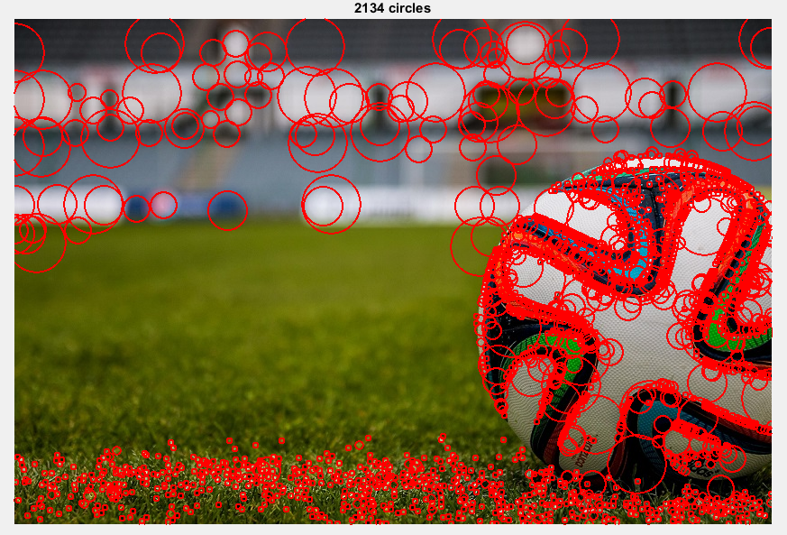

DoG method:

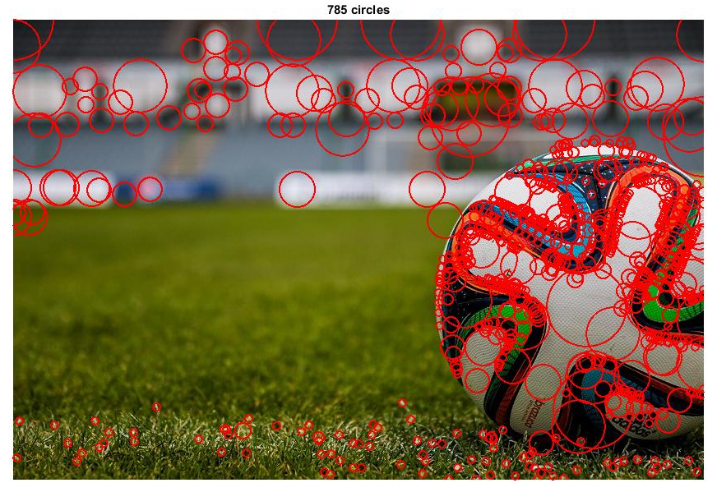

* **Hayes Hall UB**
* Why this image? Image with many different objects and intensity changes overall.
* k: 1.50
* num of levels: 4
* sigma: 2.00
* threshold: 0.0080

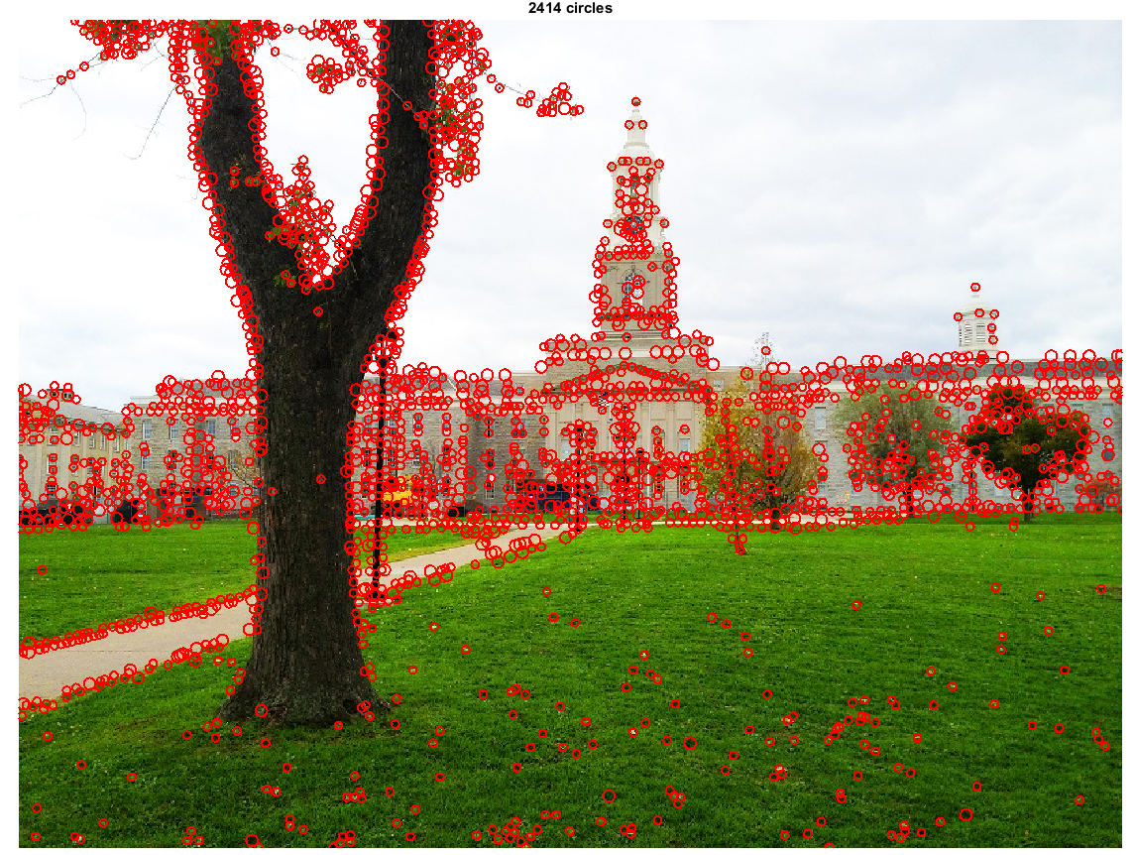

Up sample filter size method output:

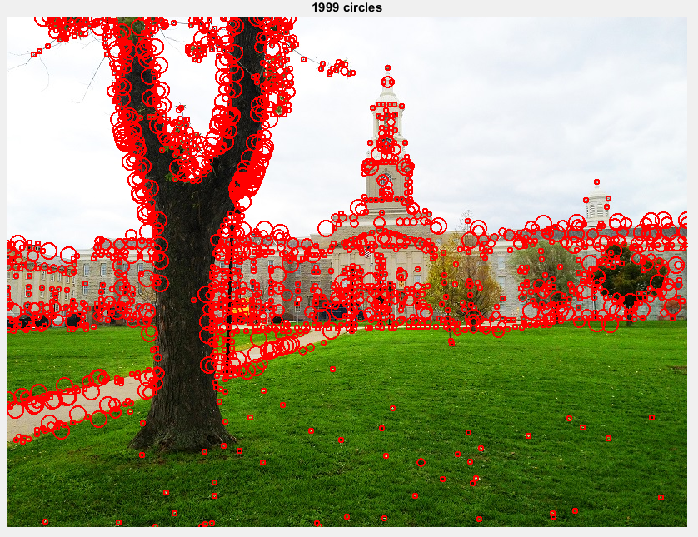

DoG method:

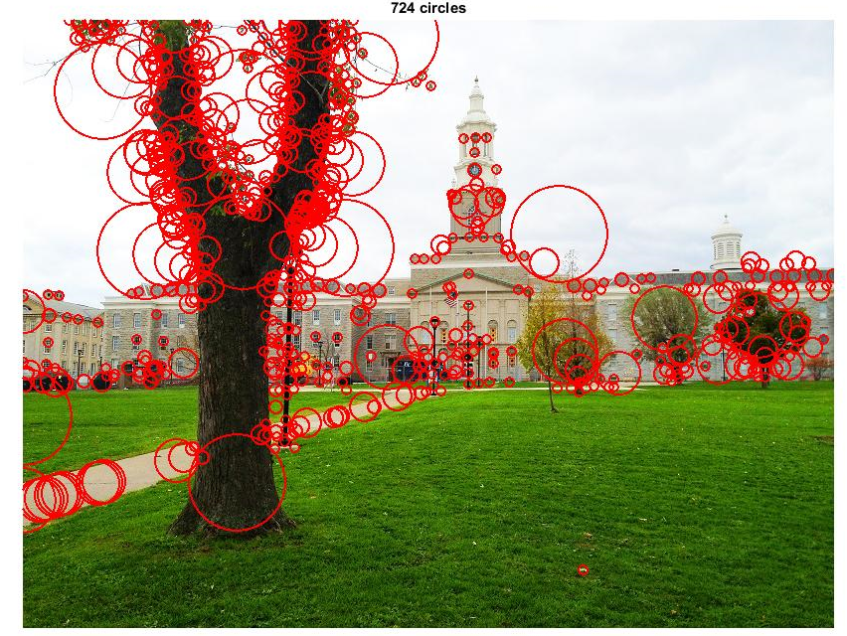

* **UB Stampede**
* Why this image? Great color difference with the background and cloud.
* k: 1.50
* num of levels: 5
* sigma: 2.00
* threshold: 0.0070

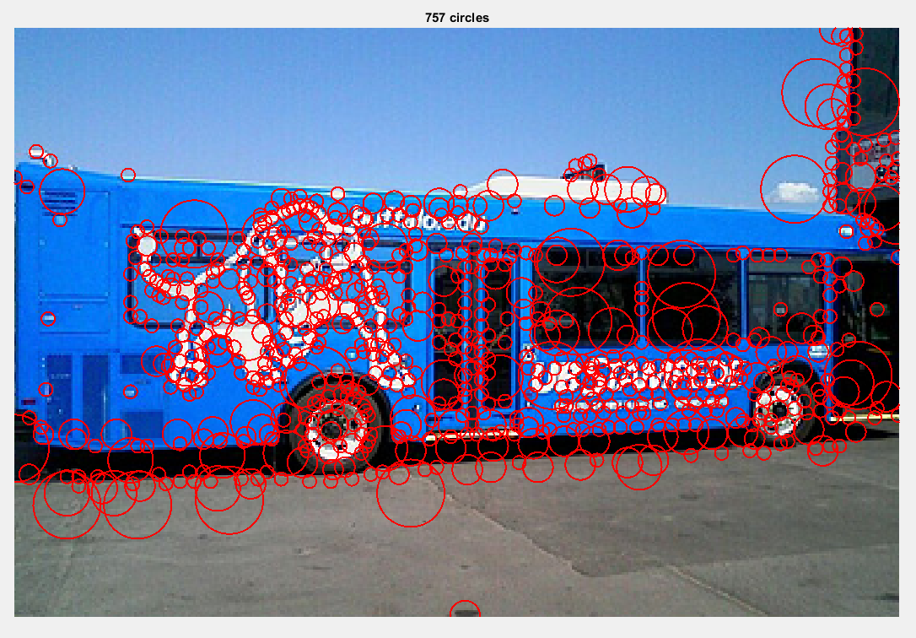

Up sample filter size method output:

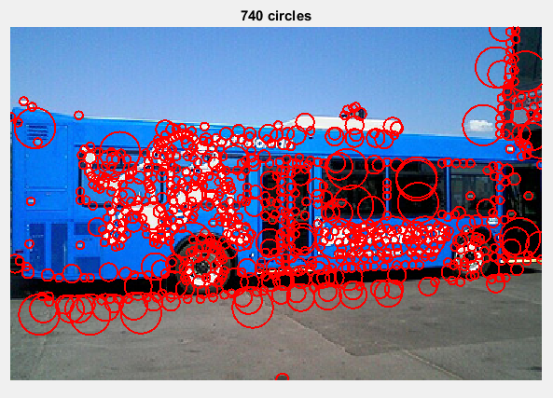

DoG Method:

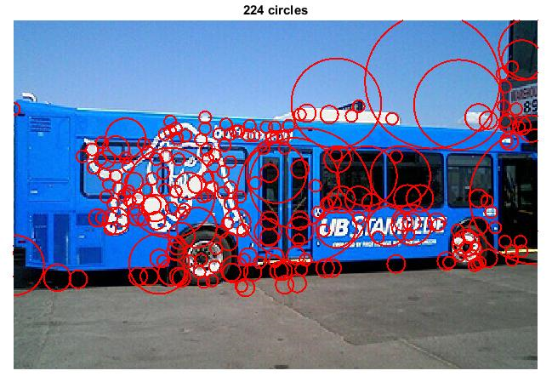

* **Zlatan:**
* Why this image? - Focused on a person with blur background
* k: 1.50
* num of levels: 5
* sigma: 2.00
* threshold: 0.01

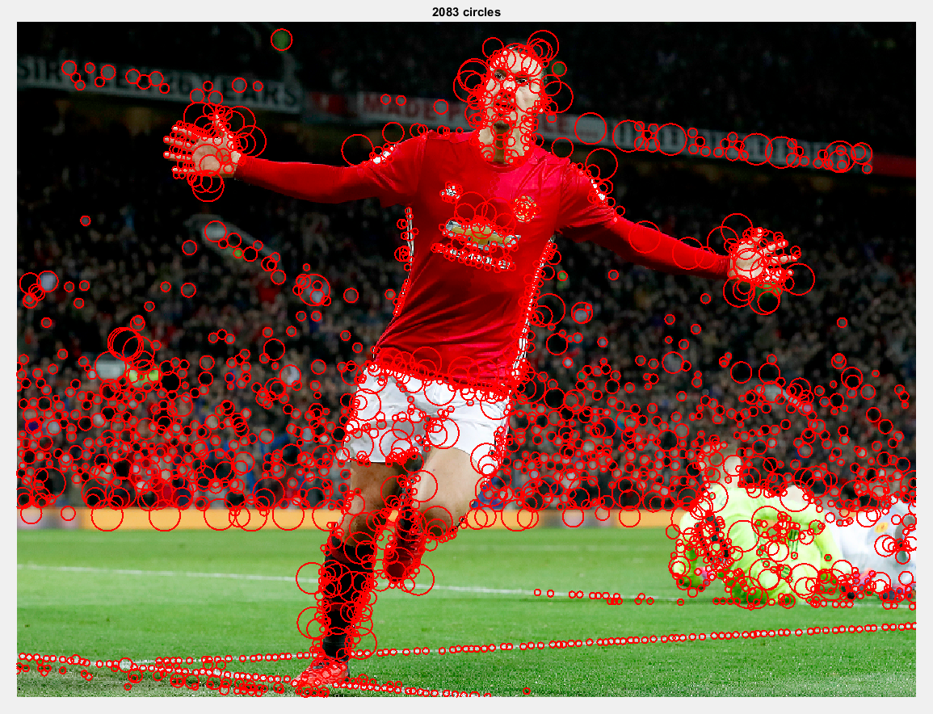

Up sample method output:

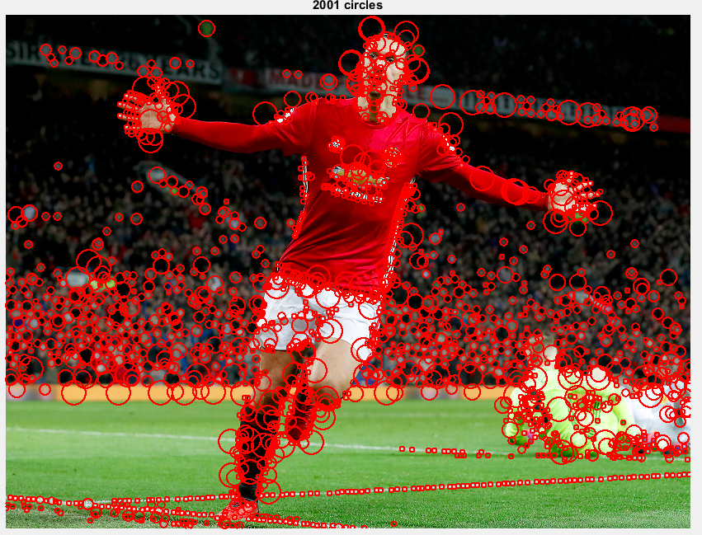

DoG Method:

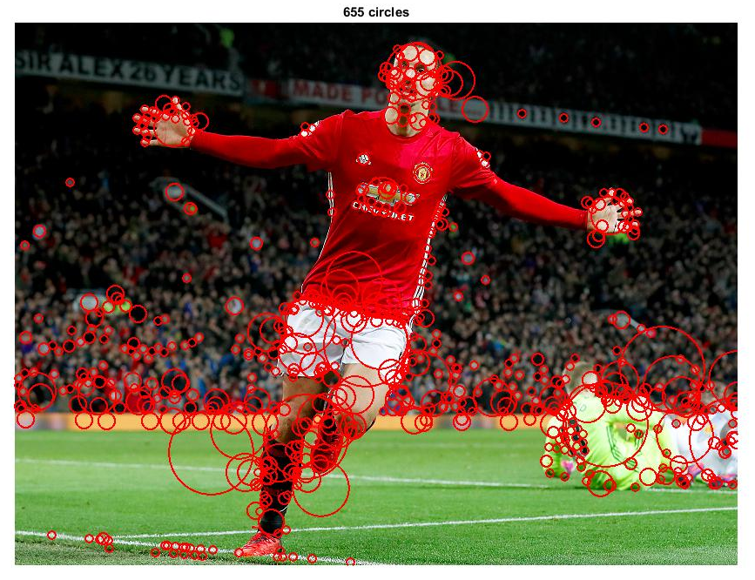

* **Manchester United Stadium**
* Why this image? Wide angle photo in daylight with glass in the image.
* k: 1.50
* num of levels: 7
* sigma: 3.00
* threshold: 0.015

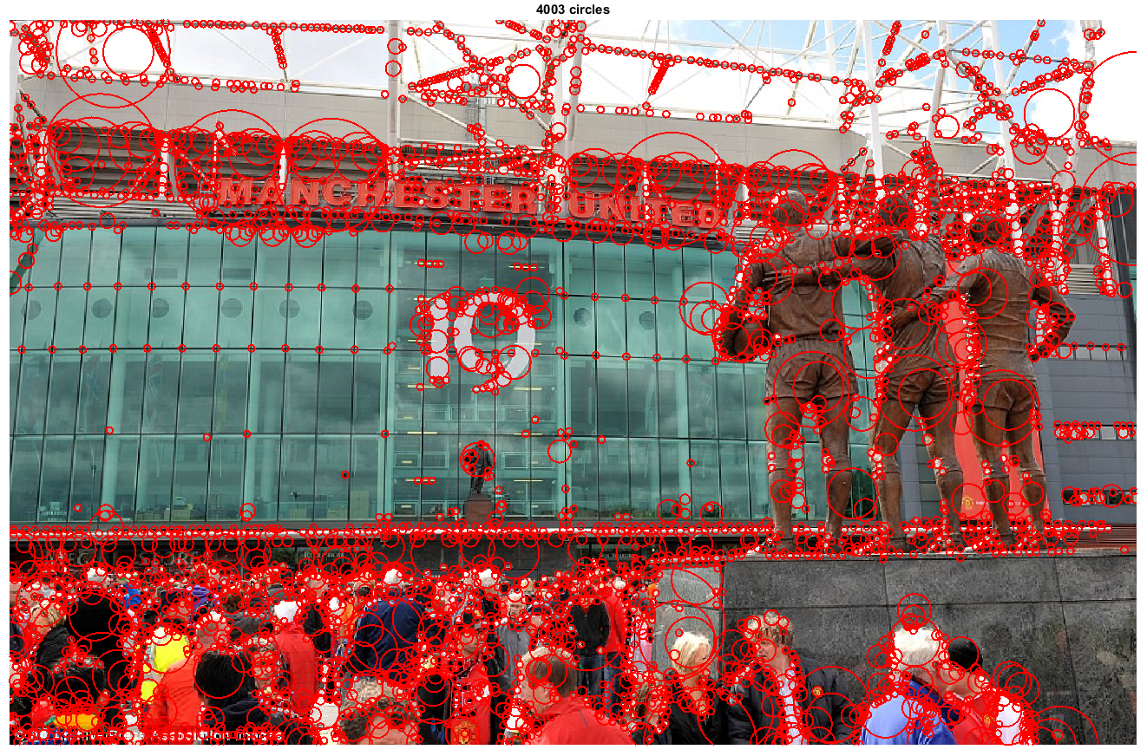

Up sample filter size method output:

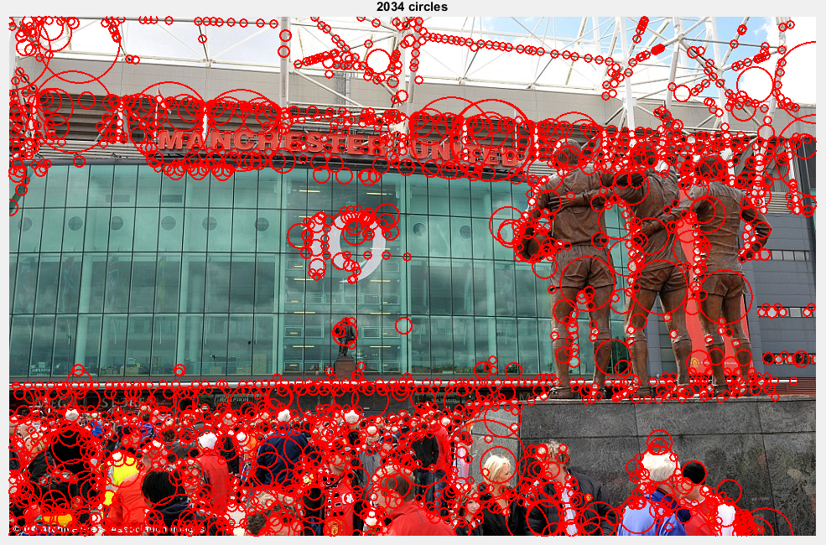

DoG Method:

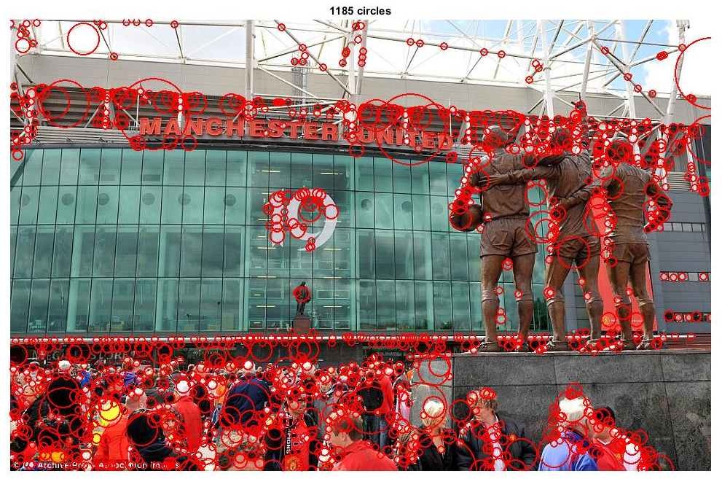

**Difference of Gaussian filters**

* Implemented differences of Gaussian filter in down sample image method and found that the blobs detected were the same.
* From the documentation on DoG, I found that Laplacian of Gaussian filter can be approximated by Difference of Gaussians Filter and the ratio of the two sigma for DoG should be = 1:1.6. So the two sigma values maintain this ratio in the implementation.
* I found LoG to be faster than DoG, the reason is obvious as in DoG we filter the image twice with the kernel and subtract the results to get the filtered image.
* Changed the threshold value for each computation to capture small blobs.

Summary

* Summary on Running Times of each image

|  |  |  |  |  |  |  |  |  |
| --- | --- | --- | --- | --- | --- | --- | --- | --- |
| **Image** | **K** | **Sigma** | **Threshold** | **Levels** | **Time taken to downsample Image** | **Time taken to increase filter size** | **Difference of Gaussian Method** | **DoG Threshold** |
| Butterfly | 1.5 | 3 | 0.01 | 7 | 0.038938 | 1.434543 | 0.067744 | 0.0025 |
| Sunflowers | 1.5 | 3 | 0.01 | 7 | 0.067593 | 1.273208 | 0.051203 | 0.002 |
| Einstein | 1.5 | 3 | 0.0045 | 7 | 0.052177 | 1.901404 | 0.09503 | 0.0012 |
| Fishes | 1.5 | 3 | 0.01 | 7 | 0.048053 | 1.380601 | 0.085204 | 0.0025 |
| Football | 1.5 | 2 | 0.01 | 7 | 0.07228 | 1.539359 | 0.13583 | 0.002 |
| Hayes Hall | 1.5 | 2 | 0.008 | 4 | 0.046271 | 0.493737 | 0.122199 | 0.0025 |
| UB Stampede | 1.5 | 2 | 0.007 | 5 | 0.017594 | 0.556258 | 0.06005 | 0.0025 |
| Zlatan | 1.5 | 2 | 0.01 | 5 | 0.0524 | 0.699209 | 0.137546 | 0.0035 |
| Manchester United Stadium | 1.5 | 3 | 0.015 | 7 | 0.095046 | 3.004962 | 0.171186 | 0.0035 |

* The increase filter size method takes more time than the down sample image method. This is because once the image is down sampled the image is filtered with the calculated filter size that does not change. Where as in increase filter size, no matter what the size of image is we increase the filter size for each layer of image. As the layer increases the filter size also increases. This increases filtering computation on the image.
* One interesting implementation that I did was that, for my machine, increase filter size takes lot of time to run. But, when I debug the code line by line it works properly. So I added a small delay for each iterating of filtering. The running times of the increase filter method includes this pause. Even though pause is added, it is much slower than down sample image added.
* The sigma and layers were selected for each image in accordance to the level of intensity change that I wanted to capture based on the image and show my understanding of the parameters that affect the blob detection.
* Also, the images, selected to detect blobs, cover various scenarios such as, focused on object with blur background. Outside image with clear lighting and many objects and bright color variation in image.
* For the given images I tried k from 1to 2 and found that for k = 2, the increase filter size method takes ages to run! The explanation is obvious, for n = 10 the filter size can be of the order of 9 as scaled k = k^(I - 1)

**References:**

* Sample Harris detector code that is provided.
* David Lowe’s paper on Distinctive image features from scale-invariant key points.
* Blob detection on Wikipedia.
* Difference of Gaussians Wikipedia
* Lecture slides
* Piazza!